Leading by global listening:
Learning from Mothers’ Union MULOA experience

We hear a lot about theory of change. It provokes strong and mixed reactions. Is it just a passing donor fad, ‘logframes on steroids’ as Duncan Green colourfully puts it? Or is it an exciting and potentially powerful way for CSOs to listen genuinely to their constituents and become agile and adaptive to the uncertainties and complexities of social development.

What matters more than the concept, is how it is done. So much contemporary theory of change practice has been reduced to someone sitting in an international agency’s head office, thousands of miles from the realities of people on the ground, writing down what they think the next funder up in the system wants to hear. This does not really help anyone, except to tick a donor box.

This morning I want to tell you the remarkable story of a radically participative theory of change process, called MULOA, that listened to over 200,000 people in 36 countries, helped breathe new life into a global movement.

The process exemplifies what would be called Open strategy in management speak today. Such approaches that extend strategic deliberations beyond the senior teams are increasingly popular in businesses. Somewhat surprisingly, perhaps from our development perspective, this is seen as a new and ground-breaking approach to strategy. Firms like Barclays, Domino’s Pizza, Daimler, IBM and Linux regularly use open strategies, while other companies, such as Amazon, Google and Mozilla use such an approach at different times. They say they do this to stay ahead of disruption, and become more agile and adaptive. As Warwick Business School put it:
“The process may be longer and perhaps more costly, but it draws on the wisdom of the crowd and a greater pool of creativity. It leads to increased commitment from staff when implementing the strategy after being involved, and it draws on insights from the ‘shop floor’ that can help make sense of a complex and fast-changing environment.”

Many NGOs and FBOs have invited limited engagement from partners in their strategy processes in the past, but the MULOA example takes this much further. MULOA shows that, even in ageing organisations, fundamental change is possible. Adaptable tools to engage peoples’ minds, hearts and spirits already exist – particularly for FBOs. But it takes courage to change yourself and to release others by genuine listening and believing that people really can do it themselves.

Where did it start?

Mothers’ Union is a global, women-led volunteer movement embedded in the Anglican church that aims to amplify the voice of stigmatised and vulnerable people. From its start in 1876 by Mary Sumner, it grew into an international social movement with over 4 million members in 84 countries.

But after 140 years it was beginning to feel its age. A number of members felt that the MU had had become inward-looking, more like an old-ladies club for mutual support. Not surprisingly, it did not attract younger members and numbers were dwindling in many parts of the world. Much of the work was ineffective, “imposing projects that did not meet the needs at the grassroots”. People felt MU the was fractured with a palpable tension between Britain and Ireland and the rest of the world.

Yet there were pockets of good practice too. When one staff member and an external consultant were evaluating MU’s work in Uganda they glimpsed the transformative power of listening. They wondered: “What if we could get everyone across the MU to do this listening process? We could bring change from the grassroots up”.

A newly appointed CEO was already concerned by the lack of clear MU identity and the nebulous Vision 2020 document that had no ownership from members. She was fortunate to identify a fund in MU reserves, restricted for ‘Strategic Regional Meetings’, which could potentially be used for a global process. With the cautious agreement of trustees MU launched MULOA (Mothers’ Union Listening, Observing and Acting).

MULOA began as a global ‘theory of change’ process that involved structured, creative listening to more than 200,000 people, including MU members, partners and the communities that MU serves. MULOA asked three simplified theory of change questions:
- WHO we serve and who and what already influences them?
- WHAT lasting changes we help to bring about in their lives?
- HOW we contribute – what are the most effective approaches and our underlying values?
Based on the responses, MULOA reached a clear understanding of who MU is, what changes MU brings and how MU works in the community and with one another; and then agreed strategic priorities and clear plans to take forward.

What happened?

MU developed an audacious process that involved:
- Getting trustee and provincial leadership support and a guiding framework
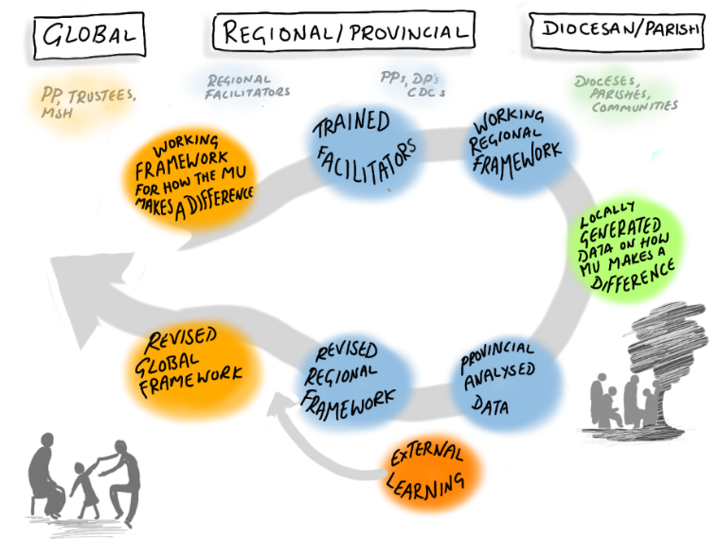
- Training regional facilitators to lead MULOA workshops
- Conducting MULOA 1 workshops in the seven regions to enable MU regional leaders to experience the methodologies, go through their own personal change and develop a working framework (theory of change) for their region.
- Taking the participatory activities back into branch groups and communities to listen to who MU touches, what changes MU helps make and how MU are or can be most effective, capturing the responses in data forms.
- Reconvening again in seven Zones for MULOA 2 workshops to analyse and consolidate.
- Analysing the Zonal feedback at a meeting of worldwide leaders in June 2019 into a global theory of change framework, a shared identity, and agreed MU strategic priorities.
- The Board and Management taking the priorities and translating them into a strategic plan for 2020-2026, approved by the Board in November 2019.

The theory of change process took the best part of two years, from Sept 2017 to June 2019. The core process cost about £200,000, paid for by the restricted fund. This represents about 3% of MU total turnover for those two years. This represents remarkable value for money given the changes it brought about.

What difference did it make?

You can read more in the paper about the remarkable changes that MULOA contributed to:

- Individual impact on MU members
- Changed attitudes and deeper faith, resulting in increased commitment and action

- Organisational impact on MU
- A coherent, collective MU identity
- Implementing a strategy focused on long-term change for the most vulnerable
Organisational impact on MU
Impact in communities
- Shift in role of the ‘UK Head Office’ from directing and funding to facilitating and capacity building
- Governance becoming more genuinely global

- Grassroots impact in communities affecting the global movement
- Self-reliance – improving livelihoods, skills for life and supporting children into education
- Relationships – within the groups, with men and youth, promoting peace and reconciliation
- Gender justice – women’s empowerment

It started from the individual. Deeply personal changes in members catalysed major organisational shifts in MU’s identity, strategy, structures and ways of working. It created a member-led, evidence base for MU global strategy that reflected localised priorities. Together with concurrent shifts in MU governance, MULOA contributed to a genuine shift towards a more truly global and interconnected movement. This has helped MU become more agile and adaptable in responding to the COVID19 crisis. It has breathed new life back into an ageing social movement.

Three main learnings from MULOA

- Mind, heart, faith dialogue at the core

The MULOA process focused on personal change first, based on the assumptions that behaviours are an outworking of our inner mindsets and that these attitudes are shaped by past personal experiences and beliefs. MULOA therefore explicitly integrated emotional and spiritual perspectives with the technical elements of sustainable change. MULOA created space for people to look inside themselves and reconnect with their sense of self; God and others. Faith is a key motivator. So MULOA explicitly and intentionally brought people’s faith into the core of the process.

The MULOA process used Bible reflections and activities to get people to listen to God, to others and think for themselves what it really meant. Bible stories such as the story of Esther, the rape of Tamar, the Widow of Zarephath, Jesus walking on water, encountering blind Bartimaeus, the woman who touched Jesus’ cloak, the feeding of the 5000 all reconnected sequentially with the three key questions of ‘who’, ‘what’, ‘how’. The facilitators used a wide variety of methods to engage with these stories, from dramatised monologues; guided mediation; role play and art. “Drama was key for us because women were used to listening to a speaker and not getting involved or having a voice”. In patriarchal Church cultures, giving people time to listen to themselves, to what God is saying, to listen to and be listened to by others and debate in a safe environment was life changing.
For many MU members, used to being told by the male priest at the front what to think, this was the first time they had done this. This use of Scripture enabled MULOA to surface highly sensitive issues such as rape, gender violence and child protection. Praying and reflecting together was integrated continuously throughout the MULOA process. This brought a sense of healing and renewed hope for many participants.

MU members strongly believe that MULOA was only transformational because there was divine power behind the changes. As one put it: “Faith is what makes the insane ideas, the impossible, possible. Either there was the same Spirit operating globally or a weird set of coincidences”. People experienced the MULOA process as a deeply spiritual encounter. They speak of the resulting changes in themselves and in MU as miraculous.

- Transformative power of structured listening

MULOA was designed on the principle that listening changes people. The whole MULOA journey started with listening: listening to self; to God; to each other; to communities and to good practice from the sector. This listening was much more than just a few interviews or focus group discussions. It was a structured and systematic listening process using participatory tools, scriptural reflection as well as drawing on outside experience. Despite the large group sizes, usually more than 100 people at a time, the MULOA process rigorously kept to participatory processes. A circular workshop layout often helped and regular group work was essential.

MULOA lived out a belief in the collective wisdom of the group. As a result, members were more willing to contribute and assist because they felt they had been listened to. Listening to communities was especially important to combat the inherent pride that outsiders know what people need. MULOA lived out a belief in the collective wisdom of the group. “What makes you think that you know better than the people who have lived here all their lives. They are the ones who have to make the changes. All you can do is walk alongside”. In South Africa a two-hour listening session with street children changed MU’s whole approach from giving food handouts to reintegrating them back into families. Yet such a complex listening process reaching more than 200,000 people in 36 countries had to keep the ensure the process itself was made as simple as possible. MULOA had:
- three principles (listening, observing, acting)
- three questions to answer (Who we serve? What lasting changes? How we contribute?)

- Appreciative, asset-based and Action-oriented

The whole MULOA message was that change came from people using their own resources. MULOA started with what people had, preventing them from being stymied by a perceived lack of resources. The sacred texts and participatory exercises emphasised an appreciative asset-based approach. The ‘A’ in MULOA stood for action. Every workshop produced a tangible output and framework answering the question: ‘How can we take this forward?’ Everyone left with their own individual commitment cards and activities to undertake in communities (not just with MU members). MULOA was a call to practical action.

Three messages for SMC members

MULOA shows that a theory of change process, if done well, can be truly transformative. MULOA helped breathe life back into a global movement. The listening process provided evidence from the field to prioritise strategy in a way that was owned and implemented. MULOA led to action and changed ways of working with communities across the world.

From 2019 UNICEF has explicitly worked with the principles and facilitators from MULOA to shift their engagement with multi-faith communities in social and behaviour change. Having piloted this in six countries both face-to-face and virtually, UNICEF are now rolling out this mind, heart faith dialogue globally. If a secular organisation like UNICEF can take this on, then there may be important lessons for SMC members too, showing:

- It is possible and potentially transformative to genuinely listen at scale
Theory of change does not have to be an abstract, theoretical process undertaken in the confines of an international office in order to fill in a paragraph in a proposal. Use participatory activities to listen in a structured way to beneficiaries on the ground can be transformative.

- Capture hearts and minds and connect with faith to see deep sustainable change
Find creative ways for people to engage safely in ‘mind, heart and faith’ dialogue about their realities and possibilities. Explore mindsets and beliefs that influence on-going behaviours. This is not exclusive to the Christian faith.

- It takes humble and courageous leadership
Supporting such an approach takes bold, visionary and trusting leadership. Participatory listening is uncertain and uncomfortable. A MULOA-type approach is not for the faint-hearted. It takes courage to listen and even more to act on what you hear by changing what you do.

MULOA shows change is possible in organisations and movements towards effective and sustainable asset-based development. Adaptable tools to engage peoples’ minds, hearts and spirits already exist. But it takes courage to change yourself and to release others by genuine listening and believing that people really can do it themselves. Do you have the faith and courage to go there…

MULOA EXERCISES AND BIBLE STUDIES

Commonly used participatory exercises
- Listening and burdens (adapted from Participatory Workshops by Robert Chambers)
- Listening on three levels (adapted from CDRA South Africa)
- Big Step (adapted from MU Eagle)
- Crossing the River (adapted from Training for Transformation)
- Knotty problem (adapted from Participatory Workshops by Robert Chambers)
- My corner (adapted from Participatory Workshops by Robert Chambers)
- Bean ranking (adapted from Participatory Learning and Action Tools)
- Stories of change
- Journey of change (adapted from Participatory Learning and Action Tools)
- Stakeholder influence using Venn diagrams (adapted from Participatory Learning and Action Tools)
- Relationship mapping
- Learning from Mary Sumner story

Commonly used Bible passages:
- Body of Christ (1 Cor 12: 12-31)
- Our calling (Esther 4:6-16)
- Walking on the water (Mark 6: 45-46)
- Day of small things (Haggai 2:1-9)
- Blind Bartimaeus (Mark 10: 46-52)
- Woman caught in adultery (John 8:1-11)
- Widow and Jars of oil (2 Kings 4:1-7)
- Rape of Tamar (2 Sam 13)
- The woman who touched Jesus’ cloak (Luke 8: 40-48)

