How to register and log in

SMC Humanitarian Field Manager Course

https://kayaconnect.org/course/info.php?id=1141
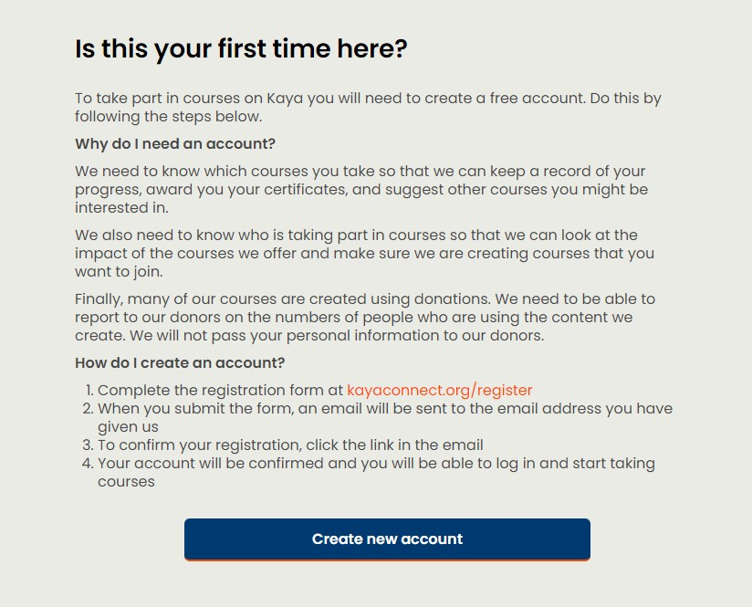

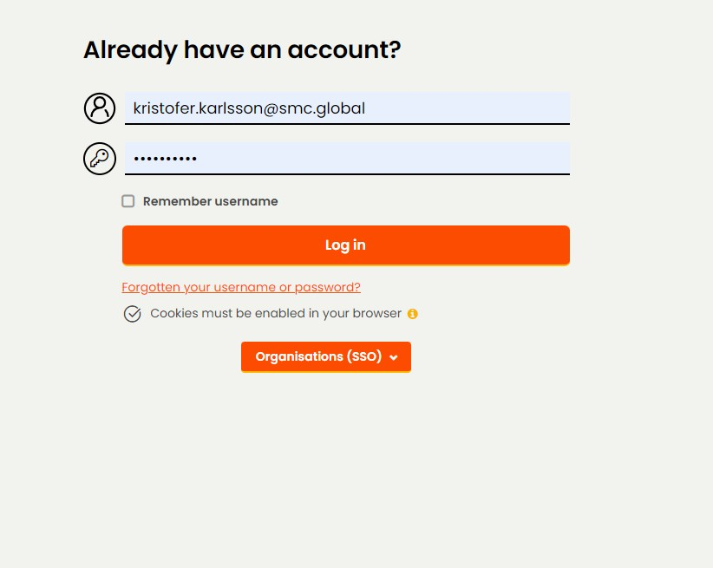

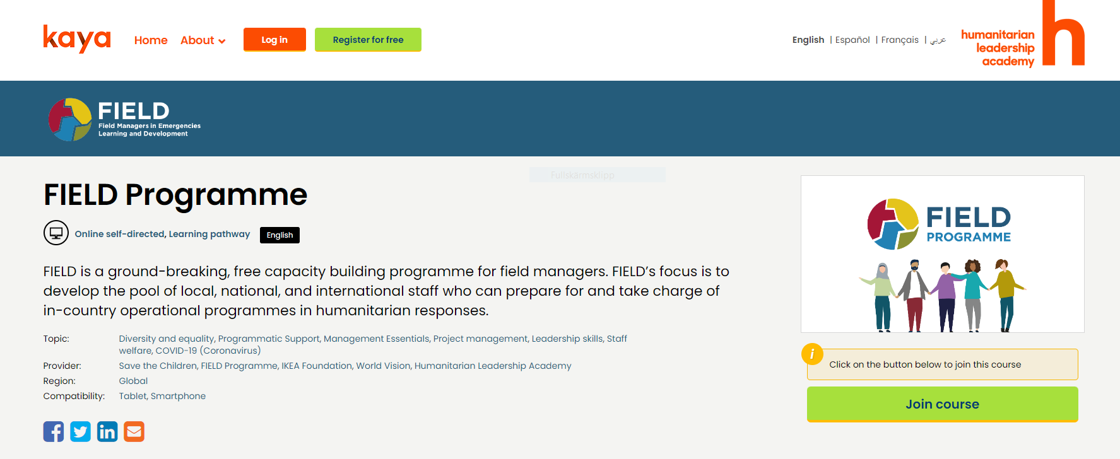

If you have challenges prompting the modules on Kaya platform please:

Ensure your browser allows for Pop-up windows, additional blockers or adds-ins don´t prevent you from accessing the modules.

Click on Settings symbol

If facing problems registering or accessing the modules
contact Kaya chat support :
https://kayaconnect.org/mod/page/view.php?id=339 Scroll down the page.

or miriam.mondragon@smc.global

If a course module isn't loading: and it says "pop-up blocked".
Some activity modules within a course open in new windows, called 'pop-ups'. If this isn't working, it probably means your browser is set to stop pop-ups from appearing. You can turn off pop-up blockers in your browser settings:
Firefox: https://support.mozilla.org/en-US/kb/pop-blocker-settings-exceptions-troubleshooting
Google Chrome: https://support.google.com/chrome/answer/95472?hl=en-GB

Kaya

How to use Kaya Mobile

We have launched Kaya Mobile on Android and iOS, available to download now from Google Play Store and the Apple App Store

Kaya Mobile allows you to access all of the online courses that you have joined on Kaya via your smartphone or tablet, so that you can continue to learn wherever you are – even without an internet connection!

Simply register for an account on the main Kaya platform; search for and 'Join' the courses that you are interested in; and then once you've downloaded and logged in to Kaya Mobile, you will see all of your courses you've joined under 'My courses'.

You can then continue to learn while on the move, as well as download full courses to your device so that they are available offline. The next time you open the app with an internet connection your progress will automatically sync with your profile on Kaya.

How to use Kaya Mobile:

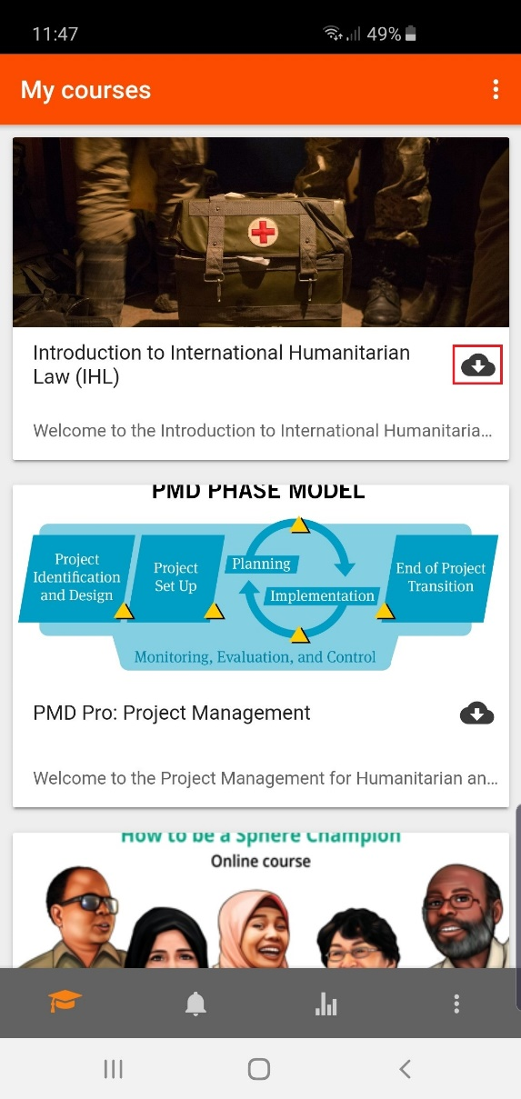
Search for and 'Join' courses that you are interested in using the main Kaya platform: kayaconnect.org

Search for 'Kaya Mobile' on the Google Play Store (Android) or Apple App Store (iOS) and download the app to your device.

Log into your account on Kaya Mobile (if your organisation has a portal on Kaya you will need to click on 'Organisations (SSO)' to access your organisation's Single-Sign-On).

You will see all of the courses that you have joined via the main Kaya platform. You can download any of the courses to your device, so that you can complete them without an internet connection, by clicking the ‘download’ button that is highlighted below (please note that this may take a few minutes depending on the size of the course and the speed of your internet connection):

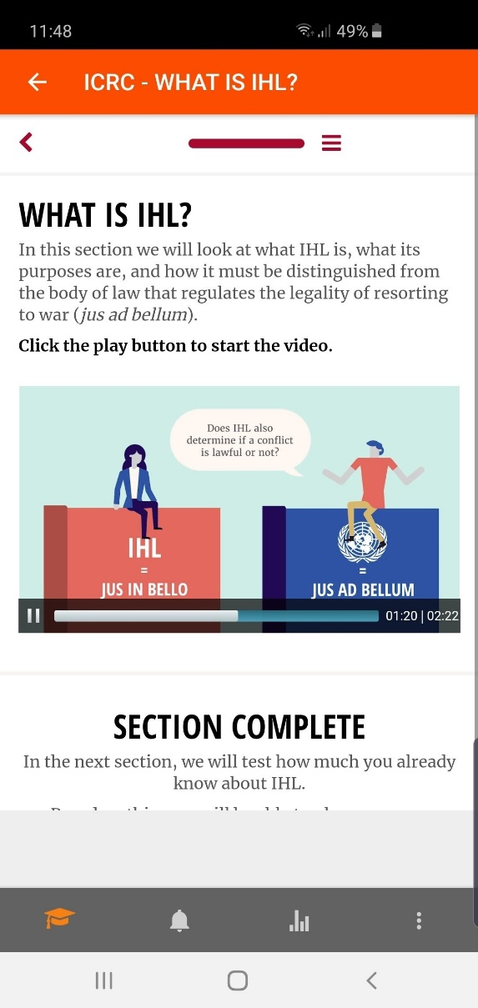
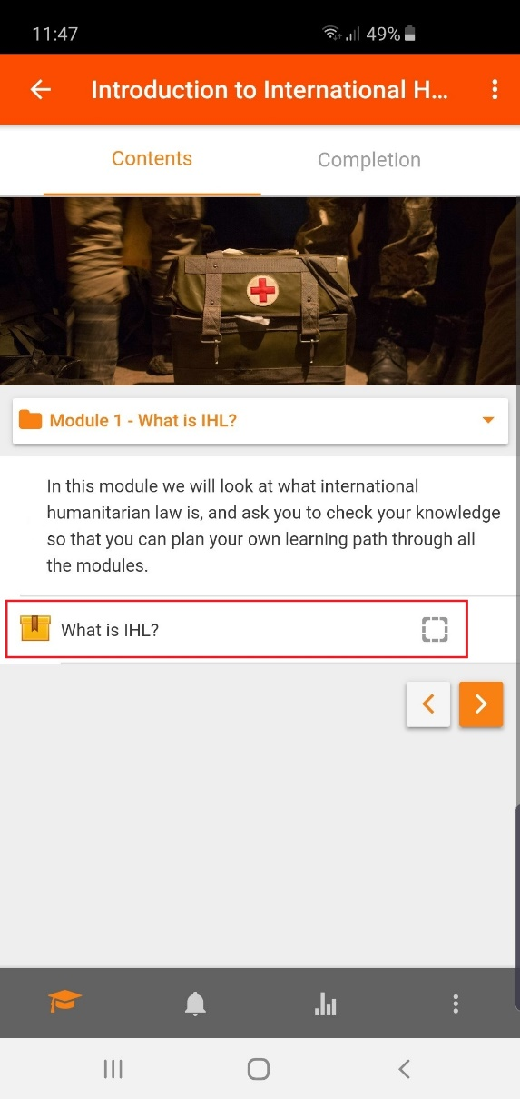
Click on the course to see the course content. Navigate the various topics using the drop down tab, or left/right buttons, and access the course’s activities and resources by clicking on each one:
Complete the activities at your own pace, even if you are offline.
When you next open Kaya Mobile when your device is connected
to the internet your course progress and completion will be automatically
transferred to your profile on the main Kaya platform.

Please note that while all Kaya courses are available through Kaya Mobile,
there may be some activities and resources within them that you won't be able
to access offline; particularly those that link to external websites. In such cases
you’ll receive a message that says that you must complete that specific activity
while online, or through the main Kaya platform.

