SweFOR Colombia
The Swedish Fellowship of Reconciliation (SweFOR) is a nonviolence movement that works for peace and justice. It was founded in 1919 by pacifist pastors who demanded that churches take a stand against militarism and war. The organization is profoundly rooted in the ecumenical movement, is inspired by the theological interpretation of the accompaniment, and its aim is a world free from violence, be it in the form of war, oppression or injustice.
The work of SweFOR seeks to promote a culture of peace and nonviolence throughout the world, promoting the pacific resolution of conflicts and respect for human rights and international humanitarian law. We consider that these axes are fundamental for the construction of sustainable peace and that nonviolence is the heart, core principle and framework of SweFOR’s method.
Through its Peace Service programme, SweFOR brings to Colombia peace observers from Sweden and other countries to accompany human rights defenders (HRD) and local civil society organizations. SweFOR’s mission is to increase their level of protection and expand the space of action of HRD who work toward the construction of a society of peace, justice, and a sustainable life for all people.
The fundamental principles in which SweFOR grounds its work include nonviolence as the most effective method to create sustainable changes in the struggle toward peace and justice. Secondly, impartiality with respect to conflict abiding parties without remaining neutral in the face of human rights violations and breaches of international humanitarian law. We accompany in solidarity those who suffer from threats and attacks because of their work as HRD. We recognise and celebrate diversity, understanding that everyone has equal value and promoting non-discrimination. Finally, we recognise the leadership and agency of local actors and we do not interfere with the priorities, agendas, and internal work of the organizations we accompany. SweFOR does not seek to changes that are not present in the demands of the local civil society, and respects the democratic structures of the Colombian State.
The accompaniment that SweFOR provides responds to the invitation and explicit request of the accompanied organizations and HRD, and therefore the actions and activities are planned and carried out in conjunction. To attain our objectives, we provide accompaniment to organizations and HRD focused on the thematic directions of land and territories, militarization of civil life and gender-based violence, and the fight against impunity. These directions are connected with the favouring factors of conflict: unequal access to the land and the use of violence as State policy.
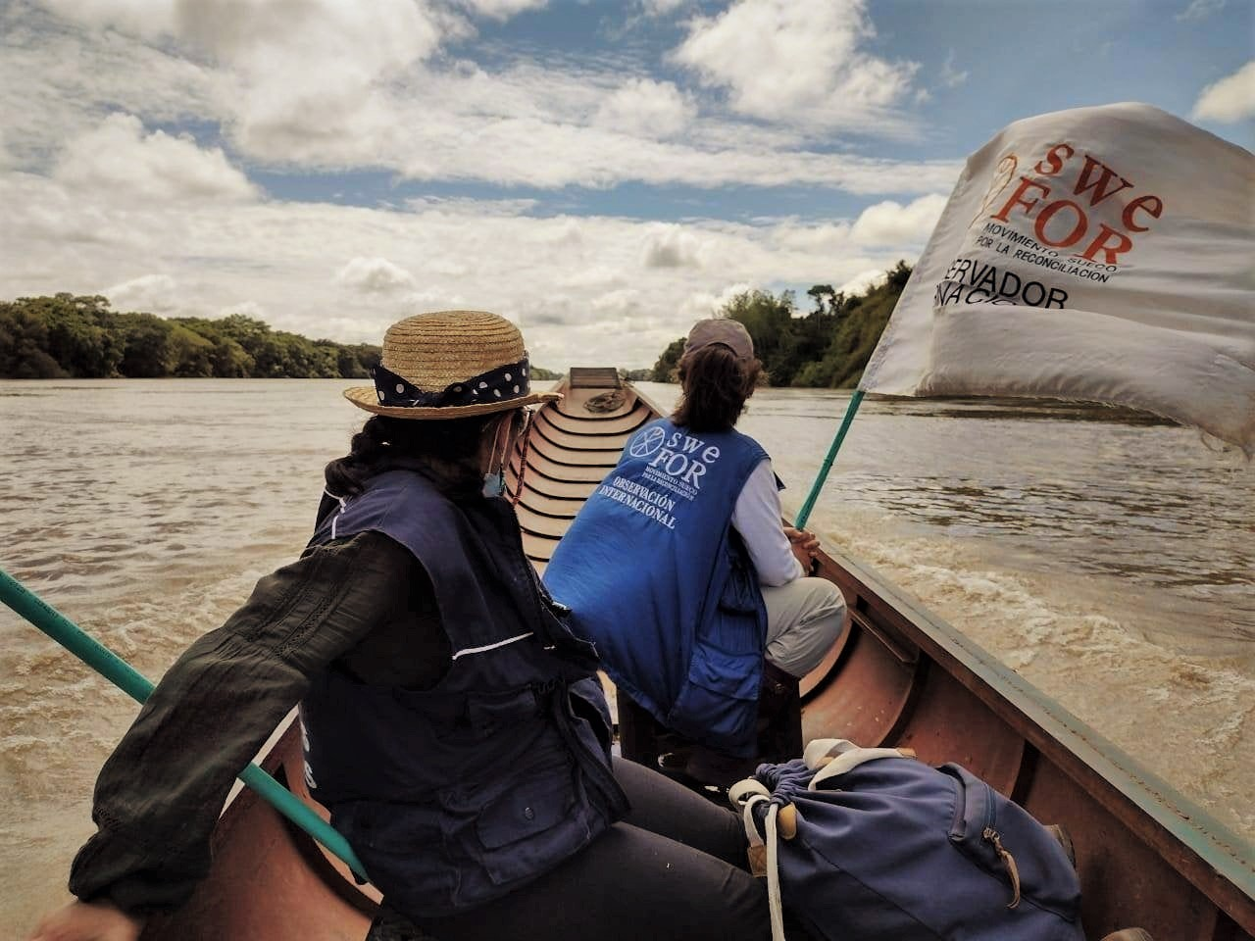
Peace Observers accompanying members of the Corporación Claretiana Norman Pérez Bello in their work in the Humanitarian Space, Guayabero region.

How we work
The nonviolent international accompaniment method that SweFOR implements in Colombia with local HRD and organizations has three main areas:
Physical accompaniment, that seeks to raise the HRD visibility and expand their space of action. We provide protection by means of our preventive presence during trips, meetings, protests and activities, making it visible and known that the international community is present and observing, in order to deter potential aggressors.
Political advocacy and strategic communications, which aims to influence national authorities and international actors on making decisions toward the protection of HRD, and the attainment of peace and justice. We articulate with local and international networks, meet regularly with the diplomatic community inviting them to visit the territories, create spaces with State authorities in which the accompanied organizations can express their demands. We use strategic communication channels to make visible the demands/concerns and the risks HRD face as a result of their activities.
Trainings in nonviolent self-protection that support and strengthen self-protection capabilities that the organizations and HRD practice. Through workshops that start from the perspective and needs of each participant, we analyse risks, capacities and vulnerabilities, and develop protection and security mechanisms, and routes that are suitable to each specific context and work.

Where we work
SweFOR attends to the requests for accompaniment from the main office in Bogotá and the regional office in Quibdó (Chocó), focused on the regions where few other organizations are present, and are most affected by the absence of civilian (non-military) State institutions and agencies.  The organizations we accompany work in different regions including but not limited to the departments of Chocó, Cauca, Meta, Vichada and the capital city of Bogotá. | 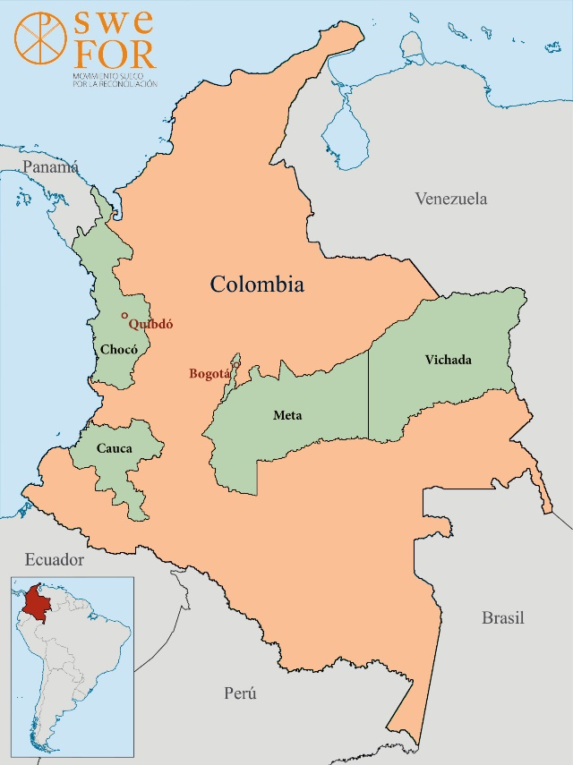

Organizations and HRD accompanied by SweFOR
Consejo Comunitario Mayor de la Asociación Campesina Integral del Atrato (COCOMACIA) is an ethnic and territorial organization that works for the defence of their right to the territorial, social and cultural autonomy in Chocó Department. COCOMACIA was founded in 1982 and was born with the close accompaniment of the Diocese of Quibdó.
The organization comprises 124 communal councils in five municipalities in Chocó and Antioquia Departments, with about 45.000 people. The organization’s board has 10 members who are elected for three-year mandates. https://www.cocomacia.org.co/
The Movement of Victims of State Crimes (Movice) vindicates the victims of crimes committed by the Colombian State, whether by its action or omission. As a movement, it demands the restoration of the rights to truth, justice, comprehensive reparation, guarantees of non-repetition, and to the memory of hundreds of thousands of men and women who work to build a Colombia in peace and with social justice.
The Bogotá Chapter is one of the 17 active chapters of Movice. Each chapter has autonomy to build and promote its agendas, and to implement its own protective measures according to their needs. It is formed by 25 volunteers, most of them survivors of crimes of the State or their relatives, and university students. https://movimientodevictimas.org/en/
Leyner Palacios was born in Pogue, a village in Bojayá, Chocó Department. As social leader, human rights defender and survivor of a massacre that took place in 2002 in Bojayá, he promotes reconciliation and reparation processes for the 33 afro Colombian and indigenous communities affected. Since September 2020 he serves as Commissioner in the CEV – the Truth Commission created by the Peace Agreement of 2016. The commission’s mission is to clarify and make known the truth of what happened in the armed conflict as a way to establish a lasting peace in Colombia
Leyner Palacios served as secretary of the Inter Ethnical Commission for the Truth in the Pacific (CIVP). The CIVP has presented ten reports focused on several regions, ethnical groups and topics, identifying patterns within the armed conflict and responsibilities of all actors involved.
Sisma Mujer is a Colombian NGO with a feminist approach, funded in 1998. Composed of about 30 women with different professional backgrounds, the organization works with women human rights defenders, social leaders, political refugees and women victims of the armed conflict, sexual and domestic violence.
Their main objective is the construction of a world free of violence against women and children, seeking freedom and equality in the exercise of their human rights. Sisma Mujer works with a psychosocial and legal approach, and a human rights approach, to strengthen social processes oriented towards individual empowerment and collective of women. https://sismamujer.org/
Corporación Claretiana Norman Pérez Bello (CCNPB) was founded in 1997 to organize and coordinate the peace and human rights work within the Claretian community. The adopted the name of a Claretian social leader who was assassinated in 1992 in Bogotá at age 25; his murder remains unpunished. Since its foundation, the CCNPB main mission is the service to the victims of violence and the farmers and indigenous communities, accompanying and promoting community processes.
Their vision is to contribute to the defence and promotion of life, the protection of the nature, and defence of human rights in order to build a peace with justice. https://corporacionclaretiana.org/

Who will you meet?

Our Team
SweFOR Colombia | Country Representative | Ingvill Breivik | 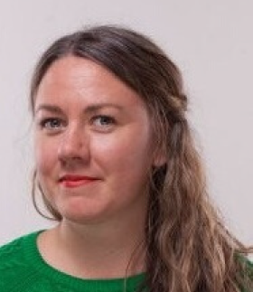
 | Head of Chocó regional office | Miriam Heins | 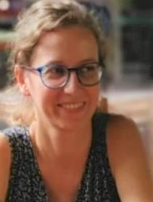
 | Peace Observer | Kalle Malmborg
Accompanied organizations and HRD
Sisma Mujer | María Adelaida Palacio | General Manager | 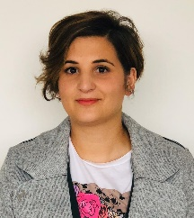
Corporación Claretiana  Norman Pérez Bello | Director | Jaime León | 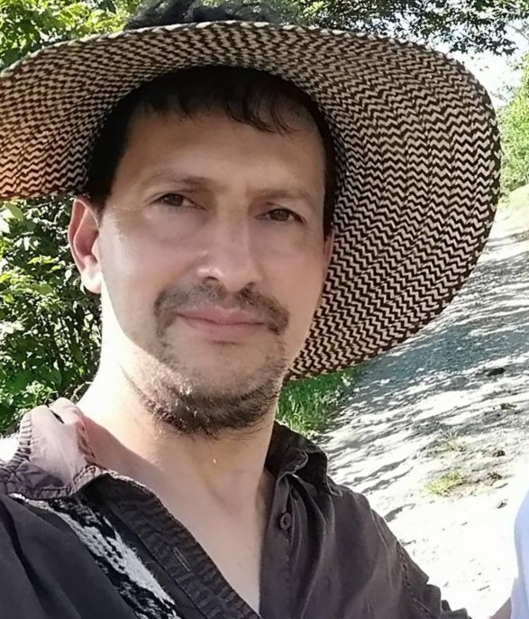
On video
COCOMACIA | Board of Directors | Kelly Johana Salas | 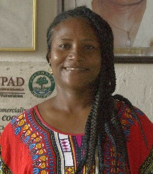
 | Vice-president of the Board of Directors | Rubiela Cuesta Córdoba | 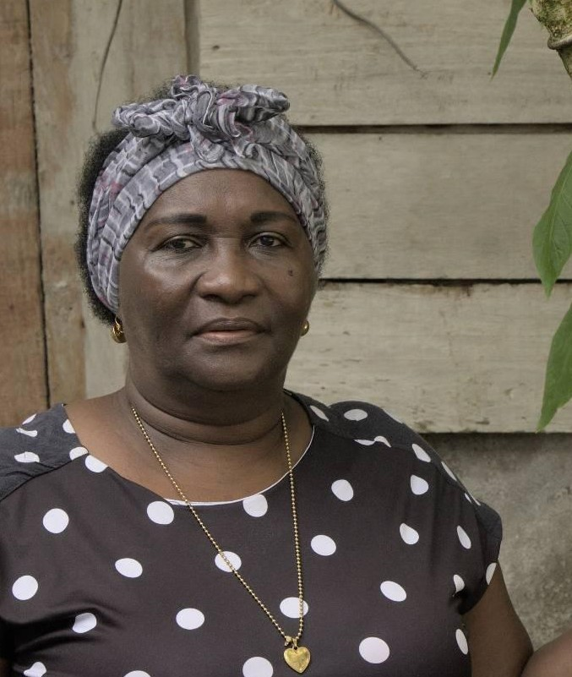
Quibdó Diocese | Parish Priest in Bellavista | Father Rogelio Salazar Gómez | 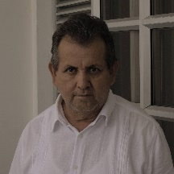

Visual material produced by SweFOR
As part of our strategic communications there are a number of visual productions aimed at bringing the stories and voices of the human rights defenders and social leaders to broader audiences, decision makers and actors who can influence in the contexts that generate risks.
- Video: Människorättskämpar från Colombia står upp för fred och rättvisa genom ickevåld. Reflections from 5 social leaders: Leyner Palacios, Luz Day García, Eliecer Arias, Viviana Pinzón and Julia Susana Mena. (1.22min)
- Video: "Inför dessa situationer kan vi inte stå tysta" - Leyner Palacios, människorättsförsvarare. Interview to Leyner Palacios, human rights defender accompanied by SweFOR (6.16min)
- Video: "Jag fortsätter kämpa, för jag är inte ensam" - Luz Day García. Interview to human rights defender Luz Day García, Porvenir, Meta (4.14min)
- Video: ”Om vi förut levde med rädsla, tvångsförflyttningar och i dödande så är situationen värre nu”. Interview to Julia Susana Mena, member of COCOMACIA in Quibdó, Chocó (5.01min)
- Video: "För mig personligen är de mänskliga rättigheterna mitt liv, mitt kall" - Viviana Pinzón. Interview to Viviana Pinzón, member of Corporación Claretiana Norman Pérez Bello (6.16min)
- Video: Paz Alianza visar att en annan värld är möjlig. Video on Paz Alianza, a network of women’s organizations working for peace in Santa Marta and the Magdalena region (5.20min)

