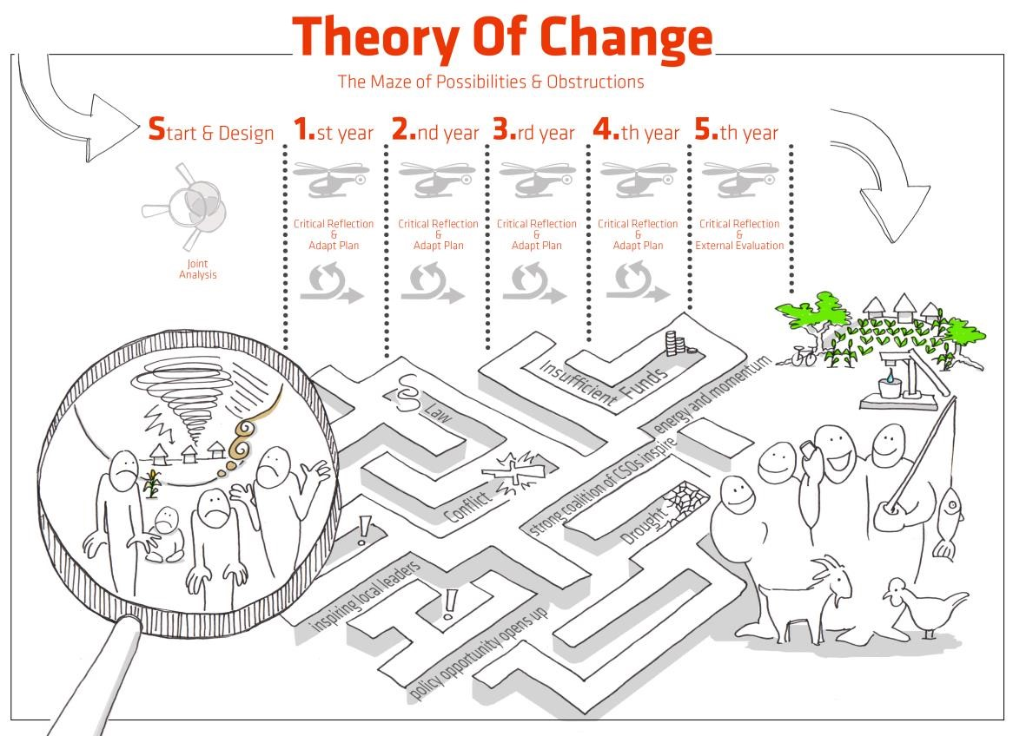
Guidelines on Applying Theory of Change in DCAs Country Programmes

List of content:

1. Introduction and Overview
2. Developing a Country Programme TOC
3. Facilitating the Annual TOC Critical Reflection workshops
Annex 1: Example of an agenda for a 2½-day TOC Programme Planning workshop
Annex 2: Example of an agenda for a 3-day TOC Critical Reflection workshop

The Introduction and Overview apply to Developing a Country Programme ToC as well as to Facilitating the Annual ToC Critical Reflection Workshops, and there is substantial overlap between these processes. Select the section relevant to your task at hand.

Introduction and Overview

Theory of Change is an approach that facilitates joint, critical, and creative thinking about change processes. It results in an agreed pathway of changes and a corresponding narrative that unfolds the joint reasoning, assumptions and risks for a project, a programme, or an organization. This model of change then informs the development, implementation and evaluation of activities and results frameworks at all levels.

Theory of Change (TOC) is DCA’s preferred approach to planning, monitoring, learning, reflecting, reporting, and documenting change in our Country Programmes.

It is a theory in the sense that it represents the best joint idea and vision of change processes at the time of programme inception. It is practical in the sense that it helps identify the necessary activities and the role of partners and DCA during the lifetime of the programme. It is dynamic in the sense that it will be reviewed every year in the Critical Reflection workshops where necessary adjustments will be made upon reflection on context changes, partner composition and the risk environment.

TOC provides good opportunities for applying Outcome Harvesting for monitoring, evaluation accountability and learning.

Planning and Implementing TOC in DCAs programmes:

Developing a Country Programme ToC
We use TOC to facilitate the design of the Country Programmes. TOC provides a valuable opportunity for current and potential new DCA partners and DCA staff to jointly formulate a common vision, to share ideas on how change happens in the context, and to agree on stakeholders’ roles in contributing to change. The TOC process also allows us to agree on key assumptions and risks, and how we will respond to these. Finally, TOC provides a sound collective basis for developing the results framework for overall management and accountability that we use to document results in the Narrative Annual Country Reports and DCA’s International Reports.
Output: A pathway diagram (see format suggestion in the PPM) including assumptions and a five-page Country TOC narrative. These form parts of the Country Programme document.

Facilitating Annual ToC Critical Reflection Workshops
We apply the TOC approach during the implementation of a Country Programme by hosting and facilitating a two-day critical reflection workshop once a year. This gives us an opportunity to reflect, discuss, and learn together in a structured way about the achievements, challenges and lessons learnt after a year of implementation. We benefit from the results of the annual critical reflection workshops in the Annual Country Programme Report, and adjust plans and activities for the year ahead, according to the learning shared at the workshop to achieve maximum efficiency and outcomes from the programme.
Output: Revised pathway and assumptions, revised five-page TOC narrative, capacity strengthening plan for DCA and partners and an action plan for the next year.

Finalising Country Programmes
During the final year of a Country Programme, the country office commissions an external evaluation of the programme. Draft findings and recommendations of the evaluation report provide input to the final Critical Reflection TOC workshop, where partners and DCA staff together discuss and agree on main lessons learnt from the entire programme period. Results from the evaluation and the workshop is used in the Annual Country Programme Report, DCA’s International Report, and for organizational learning that will influence DCA global policies & strategies, as well as informing the planning of a new Country Programme.
Output: Final programme evaluation report, overview of changes achieved, and lessons learnt for the next phase of the programme.

Link between TOC process and DCA Results Framework

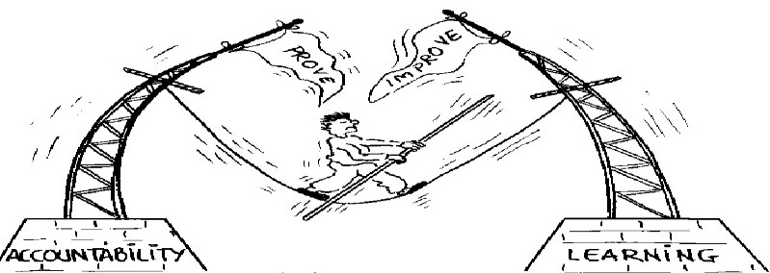

TOC processes supplement DCA Results Frameworks, and are designed to make them stronger, and to ensure that learning and adaptation systematically is embedded in DCAs Country Programmes together with our partners. TOC processes mainly focus on creating a feedback loop and on downward accountability by facilitating partner participation, joint lessons learnt, introduction of new ideas to improve projects and to adjust our role in the programme pathways. The five-page Country TOCs, the Global and Country Results Framework mainly focus on upward accountability in DCA’s management system, to keep the programme on track and to report to DCA back donors e.g., in DCA’s International Report.

The timing of the annual TOC critical reflection workshops should feed into annual reports and the process of formulating new annual plans and budgets.

Filing of TOC documents:
All Country Programme documents, including the TOC pathway and narrative should be stored in the PPD where each DCA Country Programme has its own folder. After each critical reflection workshop, the updated documents should be added. The Country Office Head of Programme is responsible for uploading all Country Programme and revised documents.

Developing a DCA Country Programme TOC
DCA country staff and the assigned advisors from DCA Copenhagen design and facilitate a workshop for DCA staff and key partner organisations. If possible, this will be a physical workshop. DCA management team summarise and prioritise the materials from the planning workshop in collaboration with the assigned advisors and the information feeds into the Country Programme formulation.
The process is described on the PPM: Phase 1: Programme Development (sharepoint.com)

Purpose: | Ensure that DCA staff and our partners are meaningfully involved in creating a joint and agreed TOC for the Country Programme.
Output: | A pathway diagram (see format suggestion in the PPM) including assumptions and a five-page Country TOC narrative. These form parts of the Country Programme document.

Key points to note:
- TOC workshops are a key consultation process between DCA staff and partners. We analyse information and data from the evaluation and the context analysis as well as insights from all participants to inform the development of concrete plans and priorities for the programme.
- TOC workshops are meant to be inspirational, motivating and energising and enabling participants to jointly reflect on how changes really happen and how we can be efficient in facilitating these changes.
- DCA staff and management must guide the processes to ensure alignment with the DCA Global Strategy, Global Results Framework and implementation Guidelines when selecting long-term change areas to focus on. This should also be reflected in the monitoring and reporting plans.
- The TOC workshop is followed by a DCA management meeting to consolidate the findings, make the necessary adjustments to programme documents (including the TOC pathway), integrate the learning in the annual plans and draft the five-page Country TOC. The CO is responsible for uploading the revised documents to the PPD.

PLANNING A PROGRAMME TOC WORKSHOP
TOC introduction:
As participants change from one workshop to the next, it is useful to make a brief introduction to key TOC concepts and methodology so that all participants have a common reference. The ToC training can either be an on-line Fabo training (some weeks before) or during the first day/session at the workshop.
Participant selection:
Participants should represent a good cross section of DCA partners across all planned DCA goals. The number of participants for a TOC workshop will differ from country to country depending on the size of the partner portfolio.
Consider inviting one or two external resource persons to act as “critical friends” to add a more objective, external perspective, to inspire new elements and approaches.

Facilitator selection:
The facilitator of the TOC workshop should either be a member of PAL or an independent consultant that knows DCA – selected in close cooperation with the management team in the country office. DCA staff play important roles in co-facilitating to ensure that partners get space to contribute to the processes.

Venue selection:
Preferably, the TOC workshops should be residential to optimise focus and efficiency
The following preparation tasks should be carried out by the HoP in consultation with the selected facilitator:

Inform workshop participants prior to the workshop:
Provide participants with:
  - Purpose and agenda of the workshop (ownership, joint planning and preparing to be able to reflect on and adapt plans in subsequent years)
  - Introduction to TOC (plus prereading if considered appropriate) e.g. from the PPM.

Prepare workshop materials:
  - Based on evaluation and context analysis – make a Power Point highlighting contextual issues that programme should address in the new programme.
  - Select and instruct DCA facilitators for the workshop (normally DCA Head of Programme and programme officers) about their role as co-facilitators for group work throughout the workshop in cooperation with the HoP and TOC facilitator. This includes agreement on preferred language to optimise participation.
  - Gather and prepare materials for the workshop processes – see the TOC Facilitators’ Guide in Fabo.org, where all group instructions and materials are available.

AGENDA FOR THE WORKSHOP
This is a generic agenda for the three-day TOC programme planning workshop. Various useful posters, handouts, standard power points presentations, and templates are available on Fabo. See annex 1 for a generic agenda for a 2½-day TOC programme planning workshop in Lebanon. Adapt according to your needs and time available.

WRITING THE 5-PAGE TOC AND PRODUCING THE TOC PATHWAY
Based on the inputs and tasks of the workshop, DCA CO management team are responsible for updating/completing the five-page country TOC and the pathway.
The five-page country TOC contains these headings:
- Analysis of context, needs and stakeholders
- Programme goals, long-term changes, and outcomes
- Why and how DCA believe changes can happen & key assumptions (3.1 Describe how changes are supported at 3 levels + 3.2 Assumptions)
- Partners, modalities, and localisation focus
- Sustainability and exit strategy
- Risks and mitigation

Find below an example of a Country Programme TOC pathway
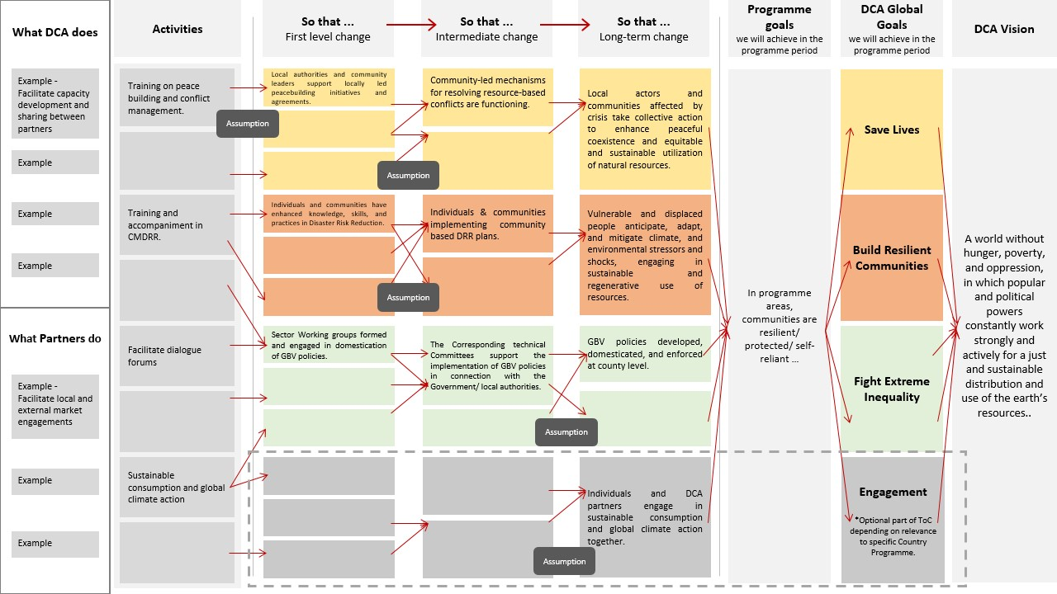
Figure 1. TOC pathway sample

Key points to note:

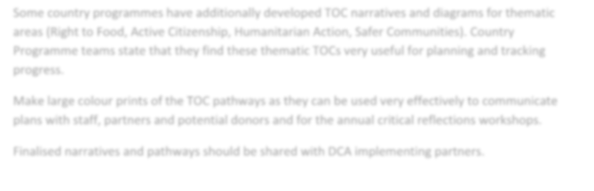
Make large colour prints of the TOC pathway as they can be used very effectively to communicate plans with staff, partners, and potential donors and for the annual TOC critical reflection workshops.
Finalised five-page country TOC (the narrative of the pathway) and the pathway should be shared with DCA implementing partners and uploaded on the PPM.

DECISIONS FOR THE FIRST YEAR OF THE PROGRAMME
As part of the planning for the first year of the Country Programme, DCA staff will need to make decisions about the areas of change that they will focus on in year one.

These are likely to be first level changes that will affect the changes to the left of the TOC pathway. Time will not allow for all areas in the change pathway to be discussed at the Critical Reflection workshop. DCA staff should prioritise up to five change areas that they will be reviewing at the first critical reflection workshop.

For each of these change areas, staff will need to consider and summarise:
- Projects and partners who will be contributing to this change area.
- What activities they will be carrying out.
- Align with Global and Country Results Framework.
- How progress will be monitored and recorded throughout the year.
This information will then be needed as starting points at the critical reflection workshop where staff and groups of participants will analyse this information and discuss progress in relation to the overall change pathways.

Facilitating the Annual TOC Critical Reflection workshops
Purpose: | Critical reflection workshops enable DCA staff and partners to reflect once a year together on how effectively Country Programme activities are leading towards desired changes; and to adapt programme and project plans in the light of this. They are designed to inspire understanding and ownership of the programme’s selected pathway to change.
Output: | Revised pathway and assumptions. Revised five-page TOC narrative, capacity strengthening plan for DCA and partners and an action plan for the next year.

Please consult the TOC Critical Reflection guideline on Fabo.org
Key points to note:
- Critical reflection workshops should be a “light touch”, energising experience where staff and partners really enjoy the process of thinking and learning together where they are succeeding and failing to influence real change for their target groups.
- Critical reflection workshops form a key consultation process between DCA staff and partners. The analysis and reflection generated at the workshop will inform plans and priorities for the following year.
- The critical reflection workshops are explicitly linked to the DCAs normal reporting cycle. They will normally be conducted at the 3rd or 4th quarter of each year during the entire programme period. Outputs from the workshop report forms a key part of DCA’s Annual Country Programme Report.
- The final critical reflection process (year 5) will involve a review of the whole programme together with findings from an external evaluation. This will become a key-learning document that will inform the development of subsequent Country Programmes.
- Critical reflection workshops should be 1-2 days and residential - if possible. If planned carefully, they can be included as a key component of the Partner Platform meetings.
- DCA staff should begin to plan for these workshops at least two months in advance; and should allow two days immediately after the workshop to process findings, make management decisions about how to adjust plans for the following year, and to write the brief Critical Reflection report. This is directly used in the Annual Country Report.
WORKSHOP PREPARATION:
Is the same as when “Developing the Country Programme TOC” (see above section 2) when it comes to which participants, numbers and briefing of participants.

The first Critical Reflection workshop will be facilitated by one of DCA’s PAL advisors. HoP and PAL lead person agree on this when the Annual Plan for next year is drafted – normally in October the year before.
It is also recommended to consult with some of the partners in the preparation phase before the following preparation tasks are carried out in consultation with the PAL lead facilitator.

- Finalise decisions about which areas of change the reflection will prioritise: As stated earlier, DCA staff will have already prioritised areas of change that the programme planned to reflect on at this workshop. It is important to review this information before the workshop and agree if there are other priority areas of change which need to be included (e.g., they may not have been foreseen at the start of the programme but became significant during programme implementation).

- Brief workshop participants ahead of the workshop: Provide participants with:
  - A workshop agenda and clear message about the purpose of the workshop (ownership, joint reflection, adaptation of plans for the coming year).
  - With the latest version of the 5-page Country Programme TOC and the TOC.
  - A brief overview of the areas of change the workshop will be looking at (and this could include reference to the relevant partners and projects).

- Prepare workshop materials (available on Fabo site):
  - Brief PPT highlighting changes in context in the last 12 months
  - Make large colour copies of the overall change pathway. These will be used a reference point for smaller groups.
  - Work with the facilitator to prepare structured flip chart presentation formats for all sessions.
  - Select and brief group facilitators for the workshop: These facilitators will be DCA programme managers/officers. Their role will be to work with and facilitate discussions one of the selected areas of change (ideally their own programme area).

FACILITATING THE WORKSHOP:
The following draft agenda provide an illustration of the planned flow and sequence of the critical reflection workshop. It will need to be adapted according to Country Programme needs and priorities – especially it this will be forming a part of the Annual Platform Meeting. See annex 2 for a generic agenda for the three-day TOC Critical Reflection workshop in Nepal. Adapt according to your needs and time available.

THE CRITICAL REFLECTION WORKSHOP DOCUMENTATION:
At the end of the workshop, the DCA programme staff will meet to discuss findings from the workshop, make management decisions about how to adapt the programme in the following year, and update the five-page Country TOC (see headings above).

It is also recommended that the programme management team summarise outputs from the TOC workshop for use of the next annual programme country report. These bullets can be used for this:
  - To what extent is the programme achieving and influencing planned change?
  - In what areas has the programme been most successful to date? Why is this the case?
  - Where is it failing to influence planned changes? Why?
  - Are there any negative and or unexpected changes that have resulted from programme implementation? If so, what are they and why did they happen?
  - Have the main assumptions changed and why?
  - Any major programme management issues to prioritise in the coming year – which the Country Director should inform HQ about?

After the workshop, upload documents on the PPD:
The updated 5-page Country TOC, the TOC pathway, and the management summary should be stored in the PPD where each DCA Country Programme has its own folder.
It is a good idea also to upload the final workshop programme, a few photos and the list of participants.
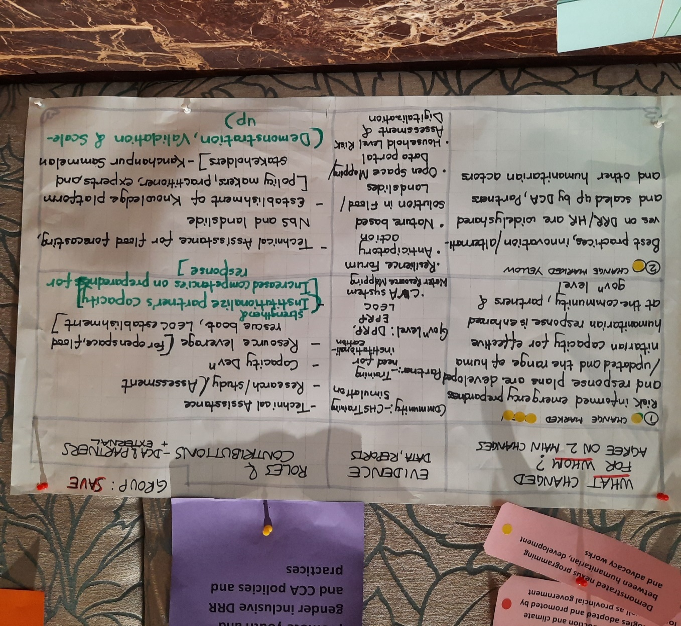
Example from TOC Critical Workshop in Nepal

FINAL WORD:
The use of TOC in DCA takes time; and we learn a lot when using the approach in each of the DCA countries every year. Hence we also update the approach on a regular basis.

Annex 1 – example of an agenda for a 2½-day TOC Programme Planning workshop in Lebanon

TIME | DAY 1: | Facilitators | Expected output | Preparation, material ready
8.30-9.00 | Breakfast and registration | DCA Lebanon colleagues
9.00-9.15 | Session 1:  Welcome and setting the scene.  Introduction of all participants. | Mike  Mirna | Welcoming everyone and sharing inspiring inputs to frame the work to be carried out the following 2½ days. | Use fun intro. method
9.15-9.30 | Introduction:  Present workshop programme, methods, and code of conduct. | Steffen & Sarah | All participants know each other and the agenda, clarification of expectations and rules for the workshop agreed on. | Have a draft code of conduct ready on poster
9.30–10.30 | Session 2: Learning from Partners and DCAs work in Lebanon until now  Presentation of key successes, main challenges, and important issues to address from partners and DCA.  DCA general observations and dilemmas on moving into HMA and HUM response to long-term development. Discussion plenary.  Localisation learning in Lebanon (NGO platforms/coordination etc.)  Financial lessons learnt – fund raising challenges etc.  Short plenary discussions/reflections. | 1-2 partners invited to present their learning and  Mike and Mirna.  Rabia | Sharing and discussion of the top 5 key learnings (Successes and challenges) to carry into the next programming phase | Prepare partners before – 10 min. presentation each.  Mike prepares slides – use concept note to elaborate.  Mirna & Stef. note down key successes and challenges on two separate posters.
10.30-10.50 | Coffee break
10.50.12.00 | Session 3: Presentation of draft context analysis  Where are we, what has changed, are we missing something and what are the main take aways from the context analysis? Experiences in working with Fight intervention areas? Rights for refugees? Civic space? | Mirna and Mike | Sharing of the current country context analysis Lebanon and inputs received. | Discuss, agree, and note down on poster / laptop.  Sarah take notes we can use to finalise the context analysis.
12.00 –12.30 | Session 4: Introduction to how DCA use Theory of Change in country programming  Q&A on the ToC methodology/approach.  Global Strategy / Results Framework | Steffen | Common understanding of the methodology to be used in the workshop, sharing of inputs for the methodology and clarifying questions | Slides prepared – based on “Updated guidelines on applying TOC approach in DCA CPs”
12.30-13.30 | Lunch
13.30-14.30 | Session 5: Defining overall country programme goal (vision), goals and Long-Term Changes  Introduction to DCA Global Strategy goals and implications for  for Lebanon pathway.  Group work 1: all groups on Save | Steffen & Mirna | Partners know DCA global goals, and we have discussed relevance in Lebanon.  Groups work on vision, goal and relevant LTCs for Save pathway. | Steffen: prepare slides  on DCA Global TOC diagram of LTCs.  Mirna: have groups and sub-facilitators ready – mixed between partners and staff.  Pre-pared posters ready for the groups.
14.30-15.00 | Session 6: Defining overall country programme goal (vision), goals and Long-Term Changes (cont.)  Group work 2: two groups on Build and Fight | Mirna and Steffen facilitate |  | Ditto
15.00-15.15 | Coffee break
15.15-15.45 | Session 6: (cont.)  Finalise group work 2: two groups on Build and Fight | Steffen and Mirna facilitates | Goals are finalized, shared and discussed in plenary. | Sub-facilitator must ensure that feedback is captured/noted down.
16.00-16.15 | Closing session:  Feedback on the day and issues for tomorrow | Mike and Sarah | Closure of the days’ work, feedback on the methodology
TIME | DAY 2: | Facilitators | Expected output | Preparation, material ready
9.00 – 9.10 | Welcome to day two and response to feedback.  Refresher of Concepts - recap of concepts of the ToC in plenary – if needed: how is a “change area” formulated? | Steffen | Presentation of the agenda for the day, expected outcomes and response to feedback. | Have definitions ready
9.10-10.00 | Café walks: presentation of group work so far on Save, Build and Fight incl. questions from the other participants | Mirna and Steffen
10.00-10.30 | Session 7: Introduction to DCA crosscutting commitments  Plenary Q&A and discussions, clarifications | Steffen & Carsten | Common understanding of DCA’s crosscutting commitments and how to ensure their integration in the country ToC. | Handout has been made by Mette and Sunra – can be shared with all before the workshop.  Stef. prepares slides.
10.30-10.45 | Coffee break
10.45-12:30 | Session 8: Developing pathways  Continue work on developing pathways for Save, Build and Fight.  3 groups (one group on each goal) for Lebanon pathway. | Steffen start up  Mirna and Steffen facilitate | Describe the pathways horizontally and vertically.
12:30-13:30 | Lunch
13.30-15.00 | Session 8: Developing pathways (cont.)  Café walks: presentation by each group incl. questions from the other participants | Mirna and Steffen facilitate
15.00-15.15 | Coffee break
15.15-15.45 | Session 9: Assumptions, risks & mitigation  Intro to session.  Groups start insert key assumptions for ToC pathways. List risks and mitigation. | Steffen  Mirna and Steffen facilitate | Groups add assumptions and risks to the pathways.  Will feed into: Part I and Risk Management Matrix | Have definitions ready.  Have posters ready.
16.00-16.15 | Closing session: Feedback on the day and issues for tomorrow | Mirna and Sarah
TIME | DAY 3: | Facilitators | Expected output | Preparation, material ready
9.00-9.15 | Agenda for the day. Feedback from yesterday. Reflections on day 1 and 2 | Mirna and Steffen facilitate
9.15-10.30 | Session 9: Partners and DCA’s role in pathways  Discuss role of partners and DCA, implementation modalities. What is realistic and concretely on localisation for/with partners in Lebanese context? What happens after clearance? New for DCA… | Mirna and Steffen facilitate | Plenary discussion on roles and responsibilities | Self-reflection needed in DCA before  Use Localisation Strategy – the 5 commitments
10.30-10.45 | Coffee break
10.45- 12.00 | Indicators for country results framework: Lebanon  Go through ToC pathways and discuss review, cleaning up and check we have all information needed. | Mirna and Steffen facilitate | Finalised pathway.  Inputs needed for DCA country programme document.
12.00-12.30 | What happens after this workshop and until programme approval, evaluation and closure of the workshop with partners. | Mike and Mirna |  | Pre-prepared evaluation – maybe online via Fabo
12:30-13:30 | Lunch

Annex 2 – example of an agenda for a 3-day TOC Critical Reflection workshop in Nepal

Time | Activities | Method | Responsible
DAY 1
Session 1 - Introduction to the Workshop
9:15-9:30 | Entering the meeting room |  | House rule Newsprint – Bharati
09.30-9.45 | Activity 1: Introduction to the workshop | Opening the workshop  Introduction | Bharat
 |  | Welcome to the participants | Welcome by Samjhana  - Introduce Alma and Mette  And handover to Alma
 |  | Introduction | Alma, organisation-wise introduction- where they are located.  - Masking tape with names in each.  - DANIDA or Back-donor or both.  (Match Box – Bharati)
 |  | Workshop Objectives, brief schedule and reminder of the major highlights from the CPD (2022-2026) | Samjhana (Explain the flow of the session)
9:45-10:15 | Activity 2: Clarification and recap of ToC & Critical Reflection(s) | What is Theory of Change - a reminder  Including the assumptions and risks | Mette
Session 2 - Changes in the Context
11:00-12.30 | Activity 3: Introduction to the context changes | Intro on the context changes  - Group Work: Formation of thematic group, and description on the role of each group (three rooms) (Discussion)  - Presentation by thematic groups followed by a discussion | Samjhana (15 minutes)  Alma  Bharat /PMs/Rajan  (Keep pathways in mind, and analyse the context based on that)
12:30:1:30 | LUNCH | LUNCH
Session 3 - Critical Reflection on Change Areas
1:30 – 3:00 | Activity 6: Assess progress on change areas in the TOC pathway | Intro to Session 3  Group work: A visual overview of the level of progress for each change area in the ToC pathway | Mette  Bharat (Roving) and PMs
 | Activity 7: Drivers and Barriers | Group work -Identify the drivers and barriers that helped or hindered progress in relation to the identified change areas | Mette - Three PMs
 | Activity 9: Assumptions and Risks | What is an assumption and what is a risk?  Definitions and examples | Mette/Alma/Samjhana-Three PMs
3:00-4:30 | Activity 8: Reflect on change areas | Group presentation: Reflect on change areas  (Gallery Walk) | Mette  Three PMs
4:30 –4:45 | Activity 10: Conclusion | Evaluation of Day 1 | Alma
DAY 2
9:15 – 9:30 | Recap | Recap of the Day 1 | Identified Partner Representative
Session 4 - Looking Forward
9:30-10:30 | Presentation on global strategy and cross-cutting  Including synergy | Includes Q and A too. | Mette (Global Strategy) and Alma (Cross-cutting)
10:30 – 11:30 | Activity 11: Critical Reflection of Findings and  Looking into the Future  (60 minutes) | Group work - Referring to the respective thematic Pathway  Group discussion  - What we could do differently? with communities and duty-bearers, new methods to be tested?, addressing potential conflict…  - Where do you see potential for upscaling? (3 up-arrows)  - Are there areas missing? (Refer to GS)  - Potential synergies between the goal pathways | Mette introduces this exercise
11:00-12:00 | Presentation in the Plenary | Plenary and Discussion on the changes of each groups | Facilitation (Alma and Mette)
12:00-1:00 | LUNCH | LUNCH
1:00-2:00 | Activity 12: Outcome Harvesting | - Presentation by Bharat/Q&A  - Use the standard format to clarify those  - Use the three examples from the outcome harvesting of 2021. | Bharat
2:00-4:00 | Partners work in a group to develop two outcome harvesting cases per theme and presentation | Group Work
4:00-4:30 | Conclusion
DAY 3
9:15-9:30 (Recap) Partner
9:30-11:00 | Activity 13: Planning for 2023 | Priorities of DCA - Presentation in Plenary  Group Work – Adjusting projects for 2023 (Focus areas, synergies) -DANIDA  What are the areas that will be different, adjusted? | Samjhana  PMs
 |  | Presentation by the PMs - Minimum Requirements and focus in each theme
11:00 – 12:00 | Looking Forward | Theme-wise - Identifying future capacity building needs and new resources.  Background: Using the information received from Half yearly Review and Reflection. | Rigendra  - Group Work and identification of capacity gaps thematic-mix  - Why and who should receive this training?  - Reaching the consensus
12:30-1:00 | Closing | Summary of outcomes  Workshop evaluation, way forward and Closure | Samjhana
12:30-1:30 | LUNCH | LUNCH | LUNCH
1:30 – 2:30 | Climate Game | Group work | Alma
2:30-3:30 | Designing Advocacy | Plenary:  - Key advocacy issues (links to 3 goals, local to global, rights-based focus)  - Prioritize  - FABO site | Mette
4:00-5:00 | Management meeting for some DCA staff  Partners and other participants – Free afternoon after 3:30 PM | - Check in on programme approval  - Prioritize training needs / HQ support

